**Billing Application Documentation**

**1. Title(BILLING APP)**

A comprehensive platform for managing invoices, payments, and subscriptions, designed to streamline financial operations and ensure accuracy, security, and compliance.

**2. Description**

**2.1 Overview**

The **Billing Application** is an end-to-end financial management system tailored for businesses of all sizes. It automates the full billing lifecycle — from customer onboarding and invoice creation to payment collection and reporting.

The application is modular, scalable, and cloud-ready, supporting deployment in SaaS, on-premises, or hybrid environments. It integrates seamlessly with **payment gateways**, **ERP/CRM systems**, and **notification services**, making it adaptable to diverse industries such as e-commerce, SaaS, healthcare, and utilities.

**Objectives**

* Reduce manual billing efforts by automating repetitive tasks.
* Provide transparency and accuracy in financial reporting.
* Ensure compliance with tax laws, PCI DSS, and data privacy regulations.
* Enhance customer satisfaction with clear, timely invoices and multiple payment options.

**Target Users**

* **Administrators** → Manage system setup, roles, and compliance.
* **Accountants/Finance Teams** → Generate invoices, reconcile payments, and run reports.
* **Support Staff** → Assist customers with billing queries.
* **Customers** → Receive, view, and pay invoices.

**2.2 Key Features**

**1. Customer Management**

* Maintain **customer profiles** with contact info, billing address, and payment methods.
* Handle **B2C** (individuals) and **B2B** (organizations) customers.
* Support multiple billing contacts per customer.
* Store preferred currency and language for localization.

**2. Invoice Management**

* Create invoices manually or auto-generate from subscriptions or orders.
* Invoice lifecycle: **Draft → Sent → Paid → Overdue → Canceled/Refunded**.
* Add line items with descriptions, quantities, unit prices, and tax rules.
* Apply discounts (percentage or fixed value).
* Generate **PDF invoices** with company branding and send via email/SMS.
* Support **partial payments** and installment billing.

**3. Payment Processing**

* Accept payments via **credit/debit cards, bank transfers, UPI, wallets, PayPal, Stripe**.
* **Real-time transaction tracking** with payment gateway callbacks.
* Automatic reconciliation of payment against invoice.
* Support for **refunds** (full/partial) and chargebacks.
* Multi-currency support with real-time exchange rates.

**4. Subscription Management**

* Create recurring billing plans (monthly, quarterly, yearly).
* Automated invoicing and payment collection.
* Handle **plan upgrades/downgrades**, prorated billing adjustments.
* Subscription lifecycle: **Trial → Active → Suspended → Canceled → Expired**.
* Retry policies for failed automatic payments.

**5. Notifications & Alerts**

* Automated **email/SMS reminders** for due invoices.
* **Payment confirmation** and digital receipts.
* **Failed payment notifications** with retry instructions.
* Admin alerts for overdue invoices or failed reconciliations.

**6. Reporting & Analytics**

* **Revenue Reports** → Income by day, month, or quarter.
* **Outstanding Payments** → Unpaid/overdue invoices.
* **Customer History** → Lifetime value, average payment cycle.
* **Tax Reports** → Breakdown of collected taxes by region.
* Exportable in **CSV, Excel, or PDF** formats.
* Interactive dashboard with filters and charts.

**7. Security & Compliance**

* **Data encryption**: AES-256 at rest, TLS 1.2+ in transit.
* **Authentication**: OAuth2 / JWT tokens.
* **Role-Based Access Control (RBAC)**: Admin, Accountant, Support, Customer.
* **Compliance**: PCI DSS (payment handling), GDPR/CCPA (data privacy).
* **Audit Logs**: Track invoice edits, payment updates, and user activity.

**8. Integrations & Extensibility**

* **Payment Gateways**: Stripe, PayPal, Razorpay, Authorize.Net.
* **ERP/CRM Systems**: Salesforce, SAP, Dynamics.
* **Notification Services**: SMTP, Twilio, Firebase.
* **APIs & Webhooks**: REST/GraphQL APIs for integration with external apps.

**3. Partcipants and their contribution in project:**

**Frontend Developers (sana, sadhana):** Designed and developed the user interface (dashboards, invoice forms, customer portal) and integrated it with backend APIs.

**Backend Developers (tharunika,pooja):** Implemented business logic and REST APIs for invoices, payments, and subscriptions with secure authentication and payment gateway integration.

**MySQL Developer (vibhav):** Designed and maintained the MySQL database schema, ensuring data integrity, optimized queries, and secure transaction handling.

4. **Login Page** – User authentication screen (Admin/Customer login).

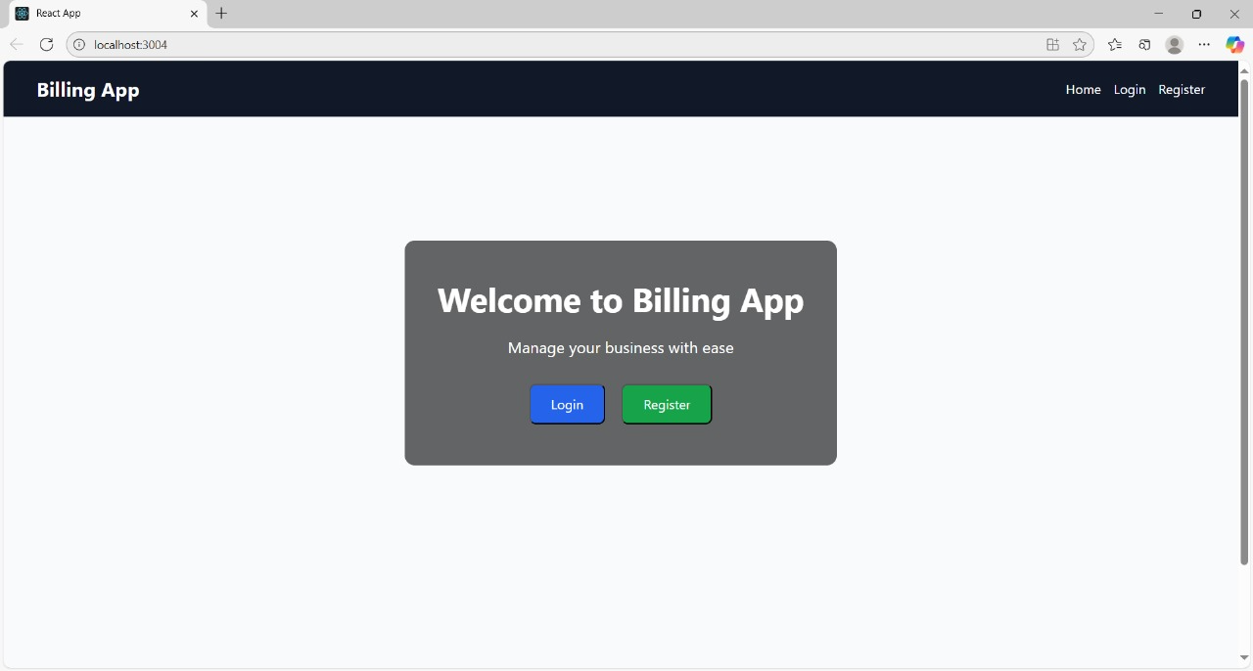

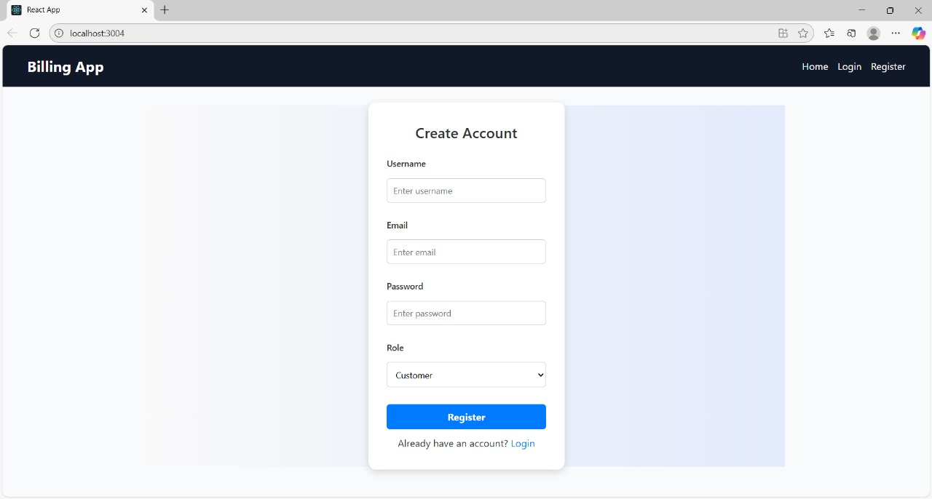

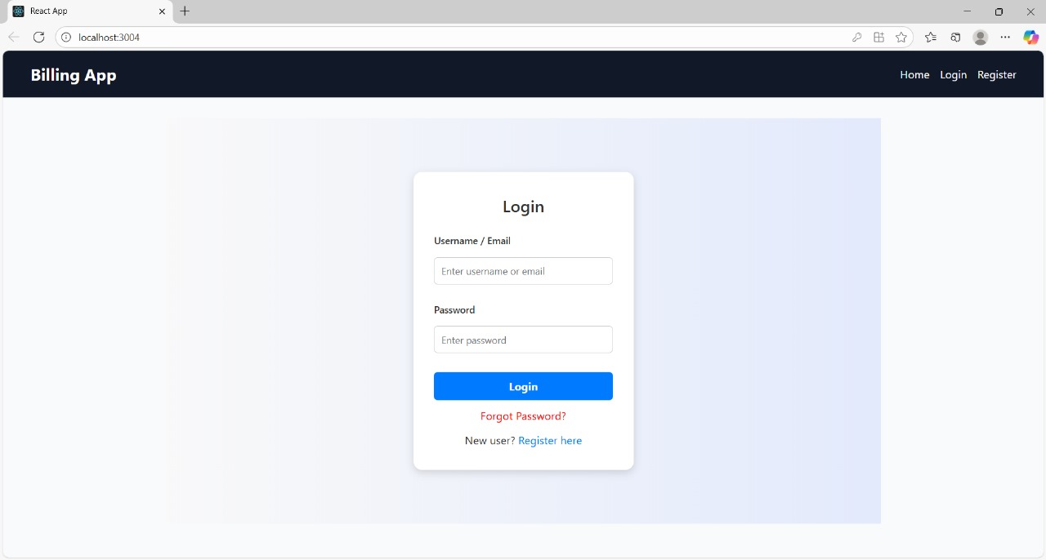

**Dashboard** – Overview of invoices, payments, and revenue.

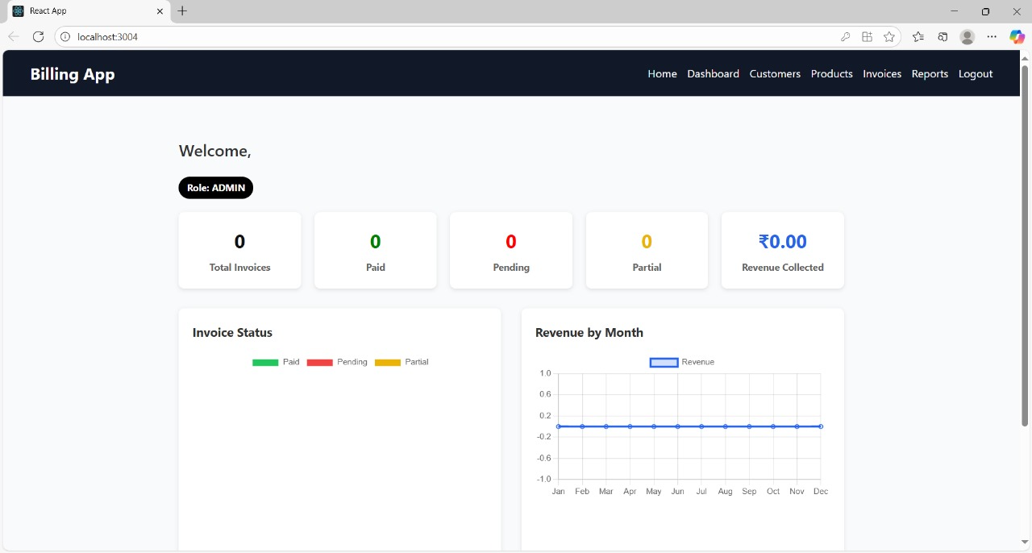

**Customer Management** – Add, edit, and view customer details.

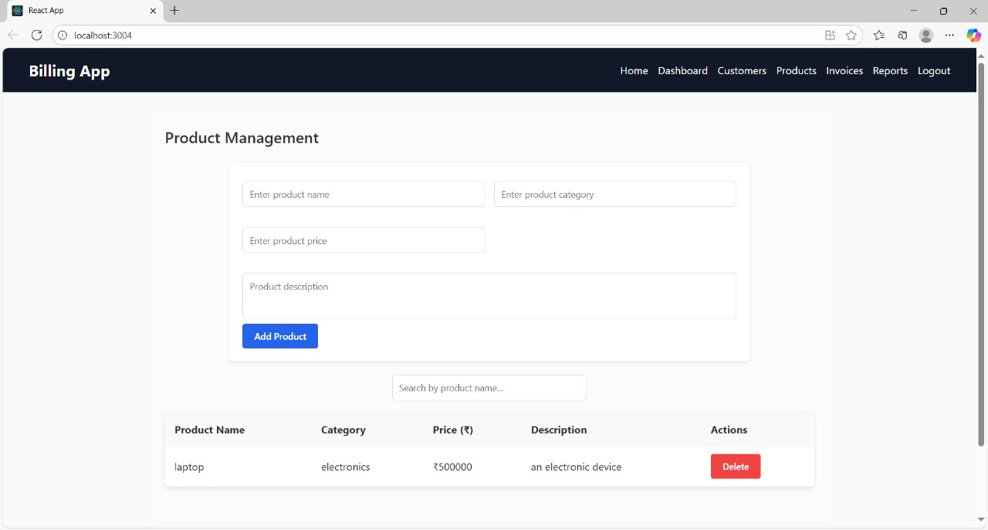

**Invoice Creation** – Form for creating new invoices.

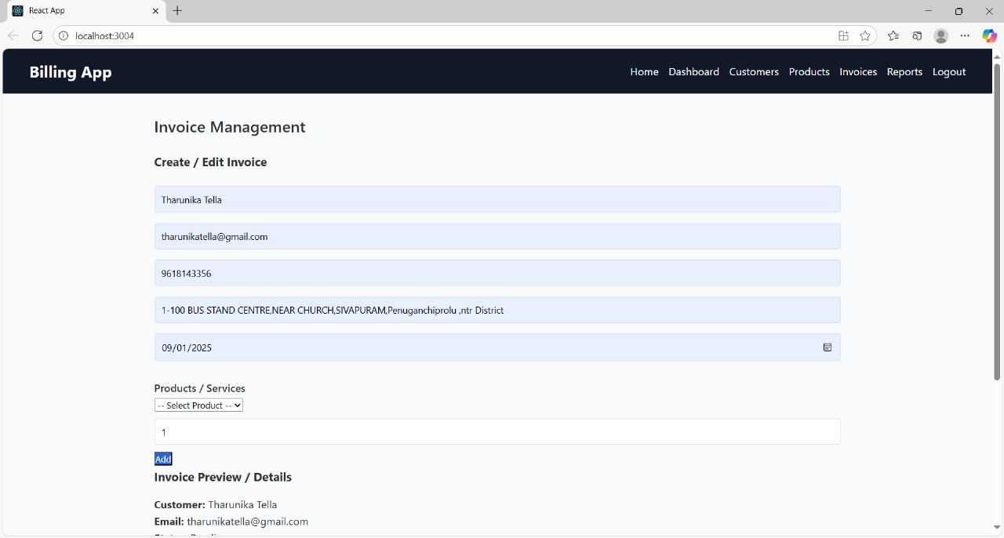

**Invoice List** – Table showing pending, paid, and overdue invoices.

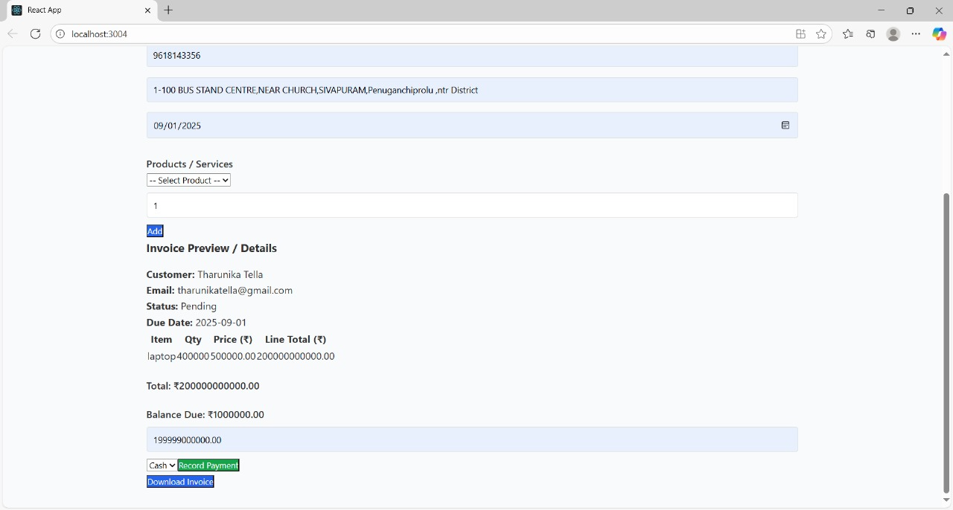

**Payment Gateway Screen** – Demonstration of payment checkout.

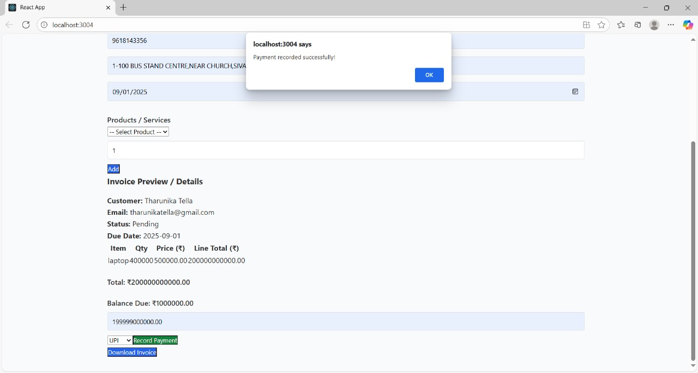

**Reports & Analytics** – Graphs and charts for revenue and outstanding payments.

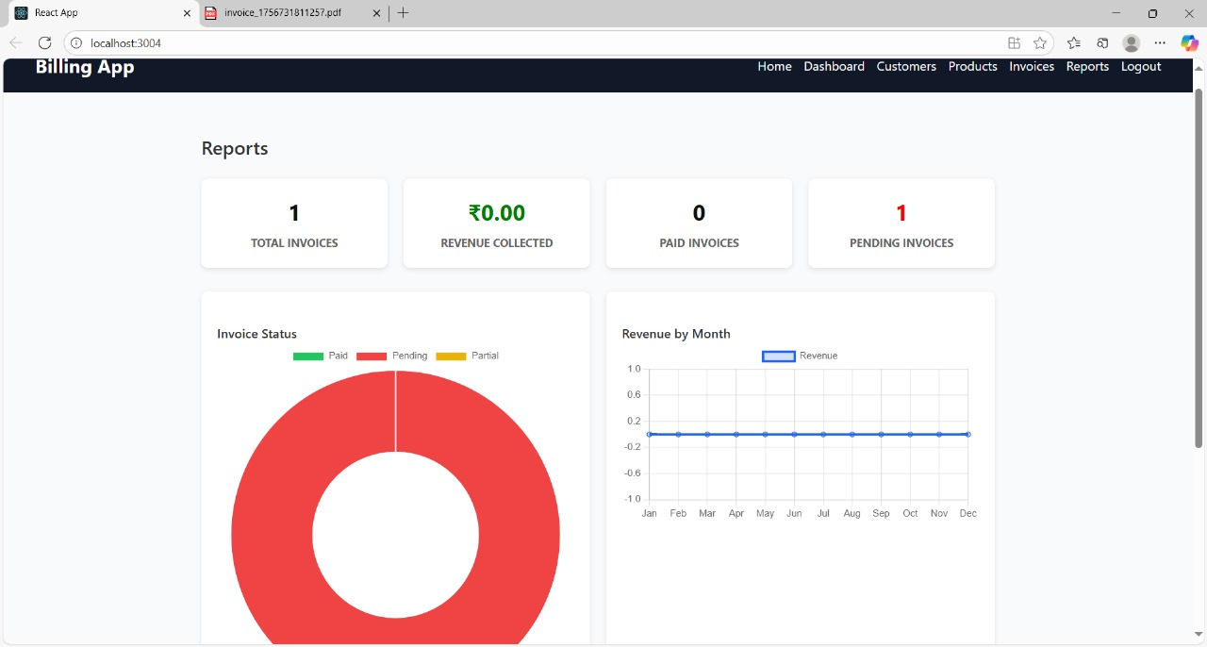

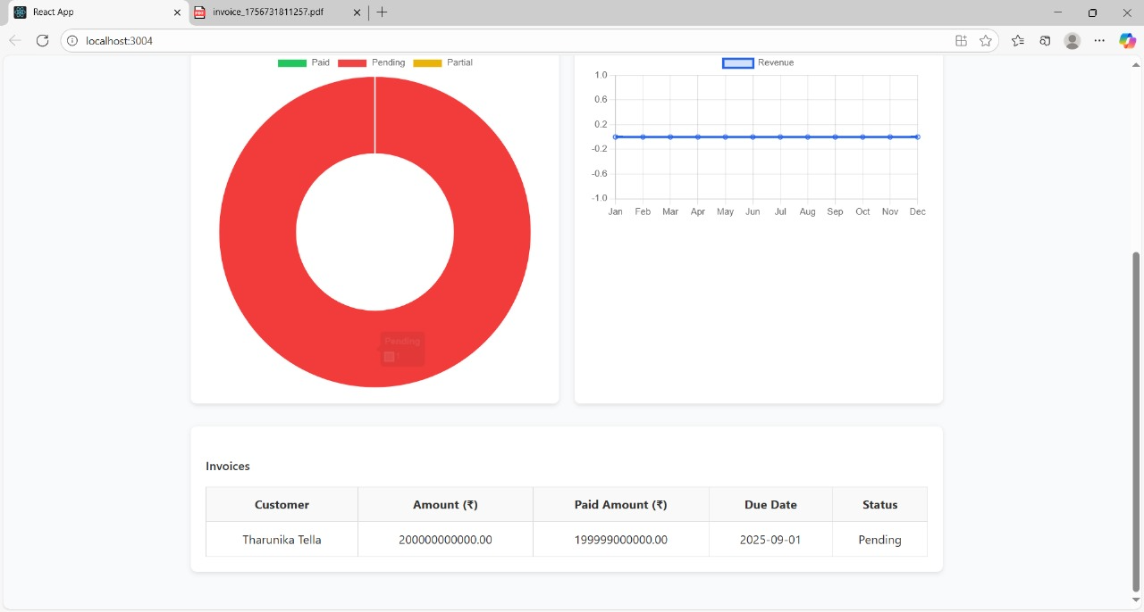

**Subscription Management** – Active plans and automated billing execution.

